**How To Draw Comics**

**Narrative:**

**Name:**

**Characters:**

Who are they and how are they important to the story?



**Setting:**

Where does the story take place?



**Story Arch**

**Diagram**

__________________________________

__________________________________

**Climax:**

The turning point;

the Problem’s Peek

**Falling Action:**

What was the Solution?



**Rising Action:**

What is the Problem?

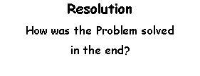

**Resolution**

How was the Problem solved

in the end?

**Exposition/Introduction:**

Introduction to Main Characters, Setting

and Background

**Resolution**

How was the Problem solved

in the end?

**Story Arch**

Consider the important plot points from the story and plug them into the diagram.

What were the problems? The solutions? The moral?

What type of story was it?



**Panel Layout Pt. I**

What will happen from panel to panel?

Think about what size and shape you want each panel to be.



**Panel Layout Pt. II**

What will happen from panel to panel?

Think about what size and shape you want each panel to be.



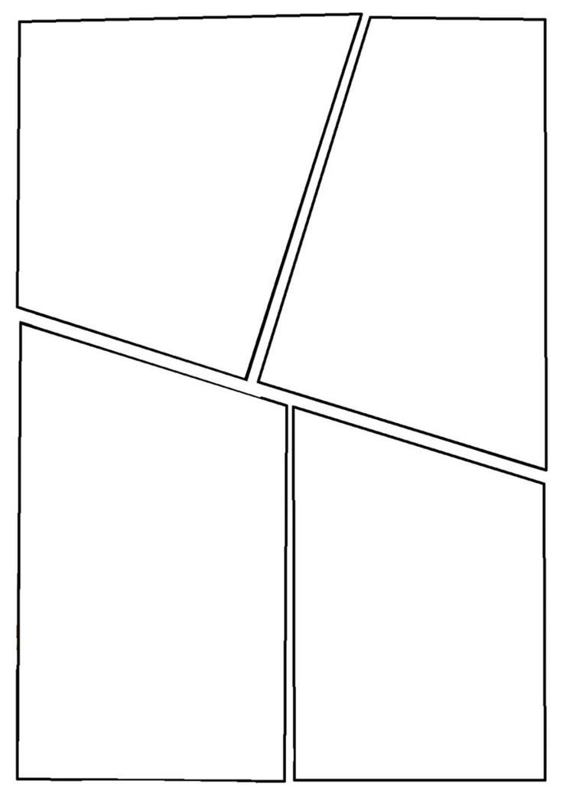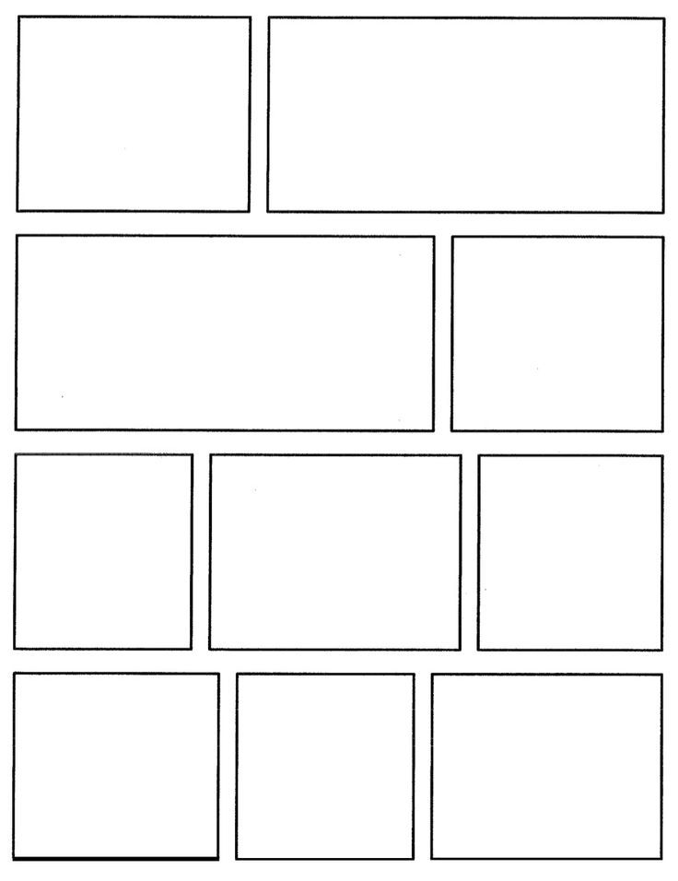

**Examples of Comic Frames**

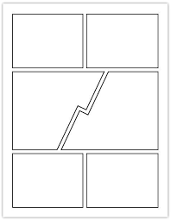

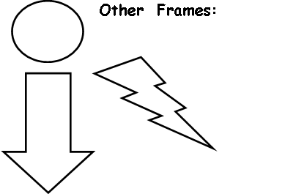

**Other Frames:**

**Examples of Action**

**and Sound Effects**

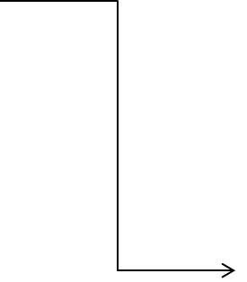

**POW!**

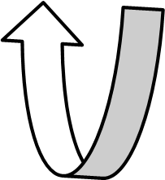

**Examples of Speech Bubbles**

**Caption: Transition (Meanwhile…)**

**Thinking**

**Talking out Loud**