How to Draw Comic Strip Characters
One of the hardest parts of creating a comic strip is drawing out the characters. As a beginner to the world of creating comic books, try not to worry too much about your drawing skills. For now, even a simple stick figure will do – In fact, there are many famous comics on the internet drawn entirely using stick figures!
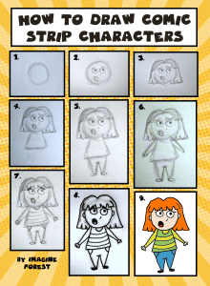
If you want more than just stick figures, you can try out the simple steps below on how to draw your own comic strip characters. For this method, you’ll start off using a light pencil to sketch your character and then you’ll add in the colour:
- Start with a simple circle.
- Draw two circles for the eye and a mouth. And don’t forget a tiny curved dot for the nose!
- Sketch any rough hairstyle. Add in the eyebrows over the hair.
- Draw triangular-looking rectangle for the body.
- Roughing sketch in the legs and tiny shoes.
- Add in your character’s arms.
- Draw in the smaller details. Don’t forget to add the tiny hands.
- Go over your sketch with a black pen.
- Colour in your character
- Your comic strip character is complete!

