How To: Paint on Denim
Step One
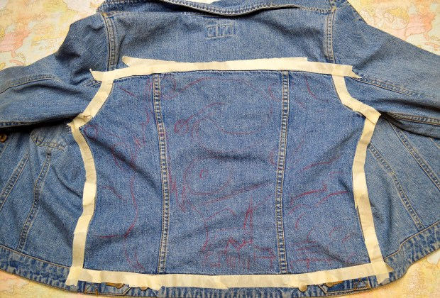
- Mix paints with textile medium:
- One part paint to two parts textile medium

Step Two
- drape denim over board/canvas and pull tight; seal with tape
- Use masking tape to section off your painting area

Step Three
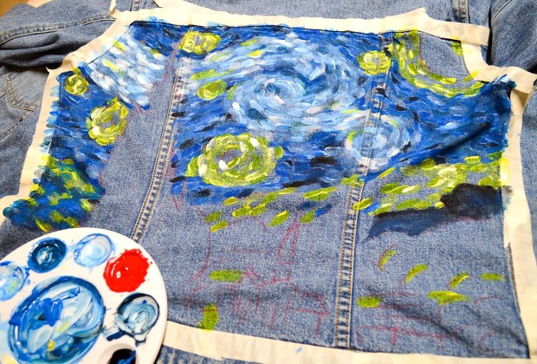
- Using a colored pencil or chalk, lightly sketch your design on your denim garment

Step Four

- using small to medium strokes, paint out your design.
- Note: painting a white base can help colours pop!

Step Five:
- After the piece has dried overnight, seal your design with heat.
- Iron it using a medium heat setting.

