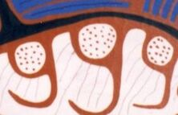
Woodland Art Handout
Lines of Power
- Lines radiating from the heads and bodies of both animals and people
- Variation in length and intensity indicate the quality of power
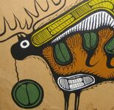
- Both transmit and receive information
Lines of Communication
- Flowing lines indicate relationships which reflect the artist’s understanding
of the nature of interdependence between two beings.
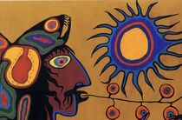
Lines of Prophecy
- Powerful creatures may have ivy-like-vines spewing from their mouths,
this indicates prophecy.
- Seen with most shamanic imagery
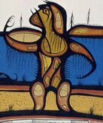
Lines of Movement
- Very short lines are indication of movement
- These lines are particularly powerful surrounding Shaking Tent imagery.
- Also, when clustered near an organ like the heart (picture example),
this could indicate an active attempt of communication with the viewer.
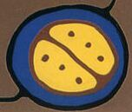
The Divided Circle
- A representation of duality
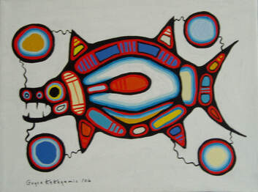
- When connected with Lines of Communication it represents the duality
of connection between worlds.
X-Ray Decoration
- representation of inner spiritual life.
Colour
- Prehistoric artist used ochre paints (ruddy reddish-brown)
- Norval Morrisseau used unmixed paints, colours that he said represented
in inner reality of the inner beings.

